Swachhta Pakhwada (15/10/2018 to 31/10/2018)
Quotations
On 17.10.2018 five motivational slogans relating to swachhta, saving of water, & switching of electronic equipment’s were prominently displayed in various places/rooms throughout GST Bhawan (GST Commissionerate), Rishi Nagar Ludhiana. Specific areas/rooms/branches where the electronic equipments were found to be switched on while not in use were specifically targeted for displaying these slogans.
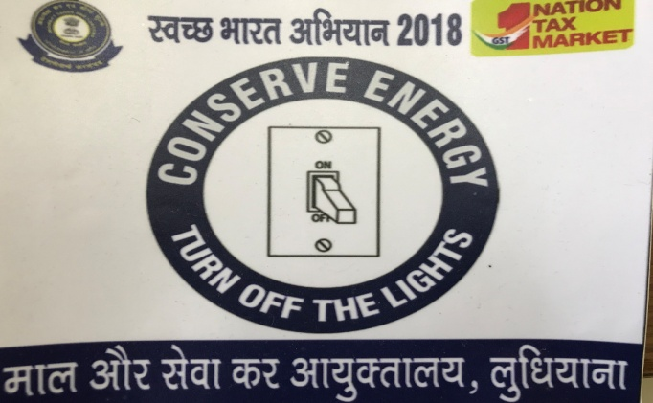
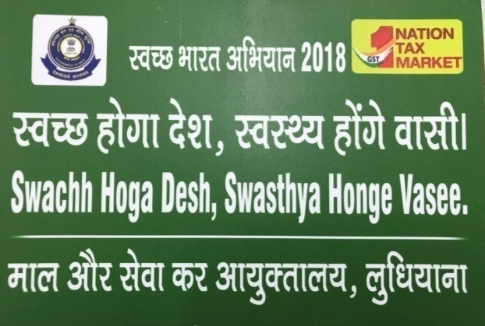
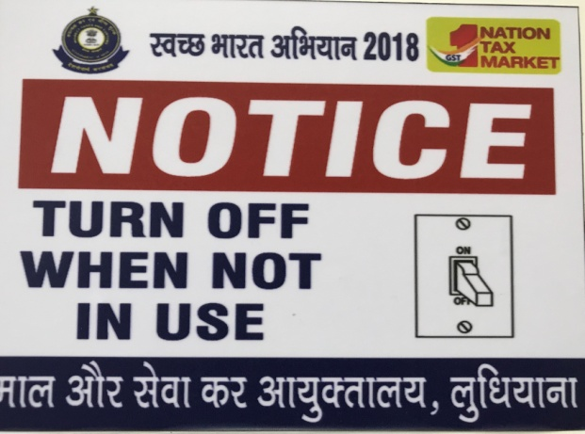
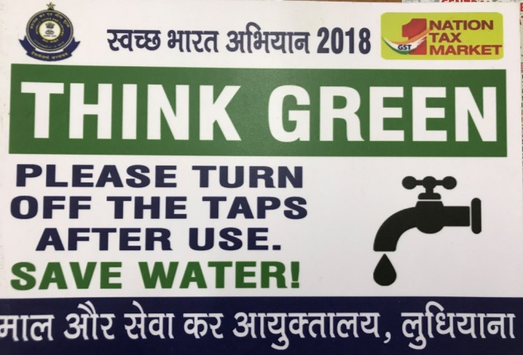

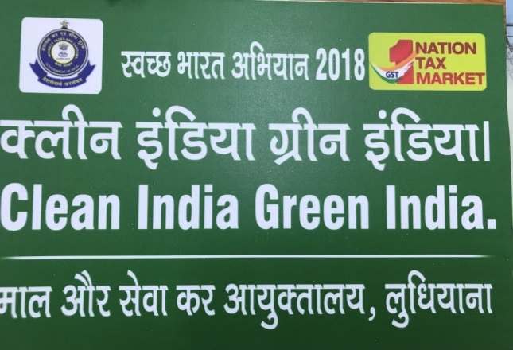

Pictures of stickers/ boards of the five slogans selected for being displayed in GST Commissionerate, Ludhiana

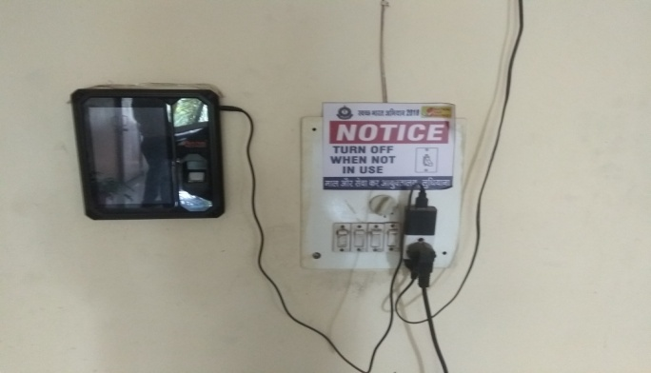

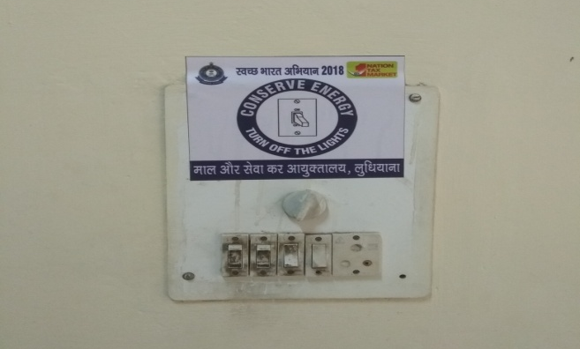
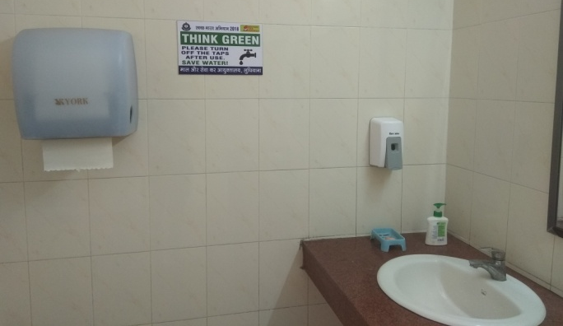

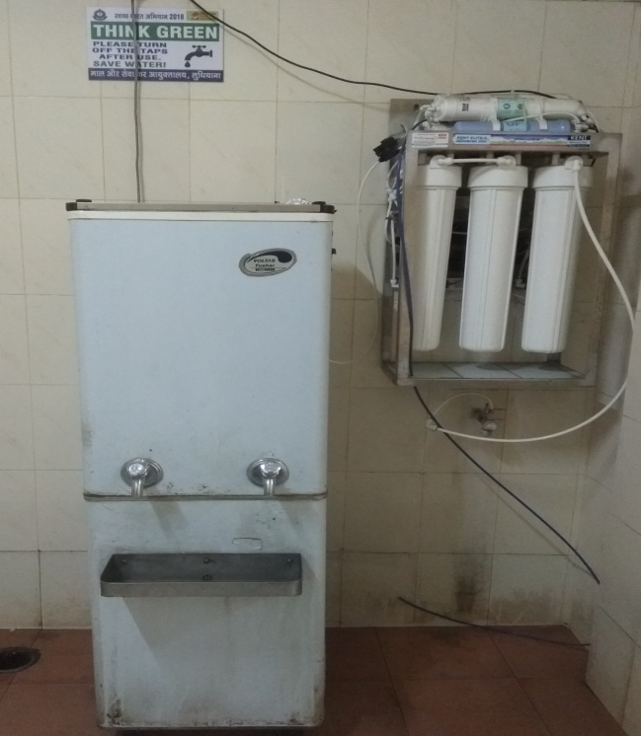

Pictures of Swachhtha slogans displayed in GST Commissionerate Ludhiana

